



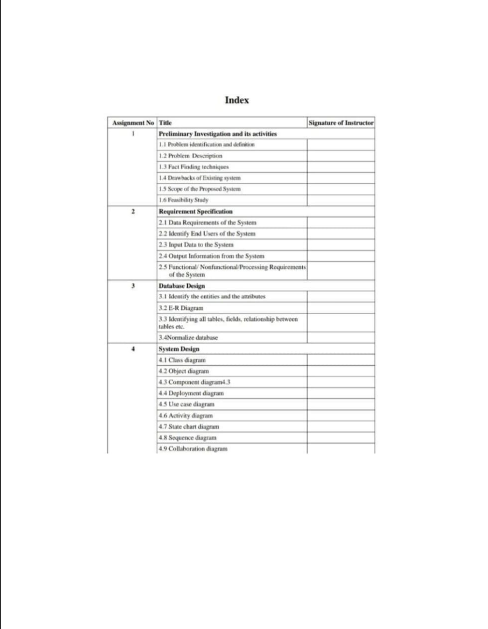

Shaddo Construction Company System

SY(BSC(Computer science)

NAME : Abdul rehman mokashi (8807)

Shadab mastan shaikh (8810)

Project Name: Shaddo Construction Company System

Preliminary Investigation and its Activities
This preliminary investigation will assess the current state of operations at Shaddo Construction Company
to determine the need and feasibility of a new system.

1.1 Problem Identification and Definition
The core problem at Shaddo Construction Company is the inefficient and manual management of
project resources. This leads to significant delays and cost overruns. Specifically, the company is facing
issues with:
• Disorganized material tracking: Materials are often misplaced or ordered incorrectly, leading to
project stalls.
• Poor labor allocation: Labor is not assigned efficiently to sites, resulting in idle workers and
overtime costs.
• Inaccurate financial reporting: It is difficult to get a real-time view of project costs and budget,
leading to financial surprises.

1.2 Problem Description
The current processes at Shaddo Construction Company are largely manual, using paper-based forms,
spreadsheets, and personal communication. The project managers lack a centralized, real-time overview
of their projects. For example:
• Material requests from the site are written on paper, then faxed or called in. The materials
manager uses a separate spreadsheet to track inventory, which is often out of date. This creates
a high risk of ordering the wrong materials or having materials delivered to the wrong site.
• Labor scheduling is done through phone calls and text messages. This makes it difficult to track
hours worked, assign the right skill sets to specific tasks, and manage overtime.
• Budgeting is a tedious process, with a long delay between a cost being incurred on-site and it
being recorded in the central office. This makes it impossible to see if a project is on track
financially until it's too late.
These issues are causing an average project delay of 10-15% and an estimated 5-8% increase in project
costs due to wasted resources and poor planning.

1.3 Fact-Finding Techniques
To gather accurate data about Shaddo's operations, the following fact-finding techniques will be used:
• Interviews: Conduct interviews with key stakeholders, including the CEO, project managers, site
supervisors, and the materials manager, to understand their daily tasks and pain points.
• Observation: Spend a day on a construction site and in the main office to observe the current
processes for material requests, labor assignment, and reporting.
• Document Analysis: Review existing documents such as material request forms, project budget
spreadsheets, and daily labor reports to understand the flow of information.
• Questionnaires: Send a short survey to all site supervisors and team leads to gather feedback on
communication issues and resource availability.

1.4 Drawbacks of Existing System
The current manual and disconnected system at Shaddo Construction Company has the following major
drawbacks:
• Lack of Centralization: There is no single source of truth for project data, leading to conflicting
information.
• High Error Rate: Manual data entry and a reliance on verbal communication lead to frequent
mistakes in material orders and labor hours.
• Poor Visibility: Project managers cannot see the real-time status of their projects, making it hard
to make quick decisions.
• Time-Consuming: The current processes are slow and require a lot of effort from multiple people
just to get basic information.
• Costly: The inefficiencies lead directly to wasted materials, idle labor, and budget overruns.

1.5 Scope of the Proposed System
The proposed system for Shaddo Construction Company will be a Project Resource Management
System. Its scope will include:
• Material Management: A module for real-time inventory tracking, material requests, and
purchase order generation.
• Labor Management: A module for assigning labor, tracking hours worked, and managing crew
schedules.
• Project Dashboard: A centralized dashboard that provides a high-level, real-time view of a
project's budget, resources, and progress.
The system will not include advanced features like financial accounting (it will integrate with existing
accounting software), direct payroll processing, or complex CAD/design tools.

1.6 Feasibility Study
A feasibility study will be conducted to assess the viability of the proposed system:
• Technical Feasibility: The system will be built using modern web-based technology, which is
widely available and supported. The company's IT infrastructure is capable of handling the
system.
• Economic Feasibility: The estimated cost of the new system is projected to be recovered within 2
years through a 5% reduction in project costs and a 10% decrease in project delays.
• Operational Feasibility: The system is designed to be user-friendly with minimal training
required. It will streamline existing workflows, making it highly compatible with the company's
operational needs and culture. The new system is expected to be well-received by employees as
it directly addresses their current frustrations.

2)Requirement Specification

🔹 2.1 Data Requirements of the System
The system will handle and store the following types of data:
- User Data – login credentials, roles (admin, employee, manager).
- Employee Records – personal info, job role, assigned projects, salary.
- Client Information – name, contact details, project history.
- Project Data – project name, timeline, budget, status, location.
- Task Details – tasks assigned to employees, deadlines, completion status.
- Finance Data – invoices, payment status, budgets, expenses.
- Documents – blueprints, contracts, permits uploaded per project.
All data will be stored in a relational database with appropriate relationships and constraints (e.g., foreign keys, not null, unique IDs).

🔹 2.2 Identify End Users of the System
The system will serve the following end users:
User Type | Description
Admin | Has full access to manage users, projects, employees, etc.
Project Manager | Can manage projects, assign employees, track progress.
Employee | Can view assigned tasks, update progress.
Client (Optional View) | May receive updates or reports (read-only, optional).
Each user will have role-based access control to ensure security and appropriate data visibility.

🔹 2.3 Input Data to the System
The following data will be input by users:
- New user registration (by Admin)
- New project details
- Employee registration and assignment
- Client information
- Task assignment and updates
- Uploading documents (PDFs, images)
- Budget entries and invoice generation
- Login credentials (username, password)
Input Methods: Through web forms, file uploads, and system dashboards.

🔹 2.4 Output Information from the System
The system will generate and display:
- Project summaries and statuses
- Employee lists and assignments
- Client project history
- Task deadlines and completion reports
- Financial reports (invoices, payments, budget tracking)
- Notifications and alerts (task due, payment reminders)
- Document previews/download links
Output Methods: Dashboards, tables, downloadable PDF reports, and email notifications (optional).

🔹 2.5 Functional, Non-Functional, and Processing Requirements of the System

✅ Functional Requirements
ID | Description
FR1 | Login/logout functionality for all users
FR2 | Admin can add/edit/delete employees and projects
FR3 | Assign tasks to employees with deadlines
FR4 | Store and update client information
FR5 | Upload and manage project-related documents
FR6 | Generate invoices and financial summaries
FR7 | Display dashboards with project, employee, and finance data

DATABASE DESIGN
Assignment No. 3 – Database Design
3.1 Identify the Entities and the Attributes
1. Project
o ProjectID (Primary Key)
o ProjectName
o StartDate
o EndDate
o Budget
o ClientID (Foreign Key)
2. Client
o ClientID (Primary Key)
o Name
o Email
o ContactNumber
3. User (Employee)
o UserID (Primary Key)
o Name
o Email
o Password
o Role
4. Task
o TaskID (Primary Key)
o TaskName
o Status
o DueDate
o ProjectID (Foreign Key)
o UserID (Foreign Key)
5. Document
o DocumentID (Primary Key)
o FileName
o UploadDate
o ProjectID (Foreign Key)

3.2 E-R Diagram 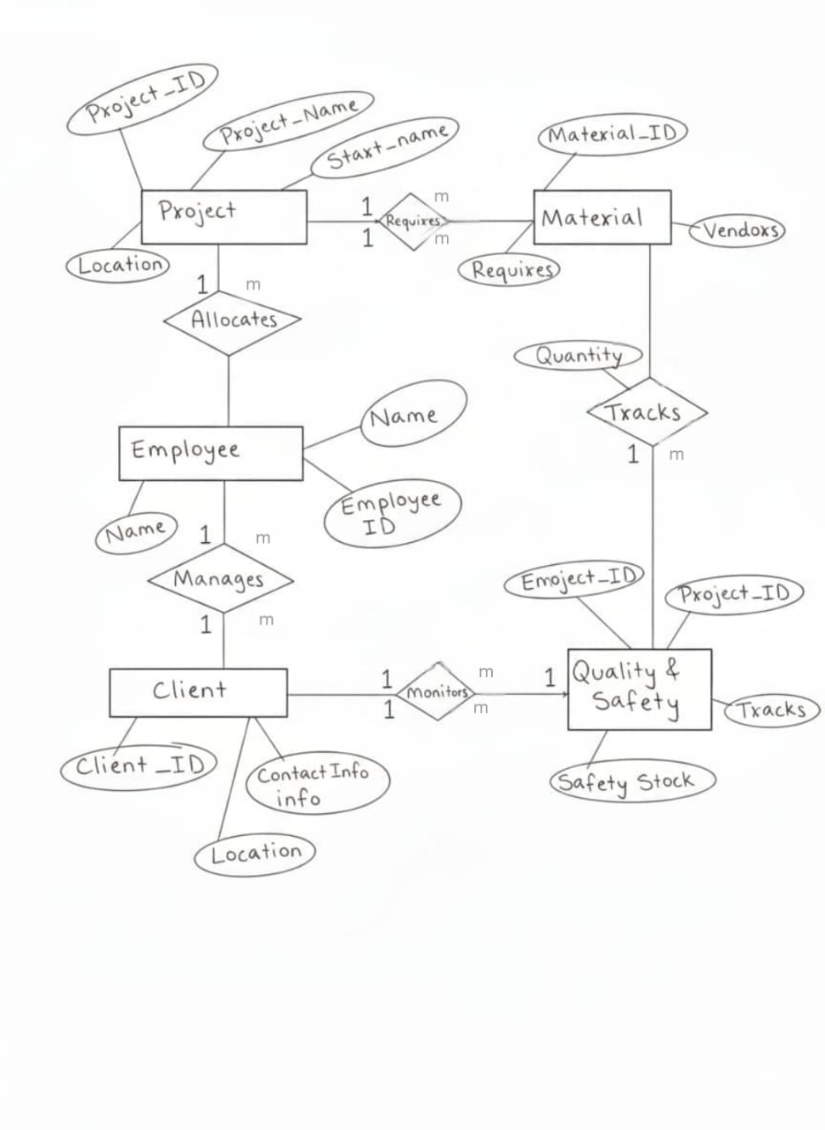

3.3 ER Diagram: Shaddo Construction Company
1. Entities and Key Attributes

ProjectID (Primary Key)

Name

Location

Budget

StartDate

DeptID (Foreign Key - links to Department)

DEPARTMENT (Represents organizational units like Site Management, HR, etc.)

DeptID (Primary Key)

Name

Location

ManagerID (Foreign Key - links to Employee)

EMPLOYEE (Represents company personnel)

EmployeeID (Primary Key)

Name

Position

Salary

HireDate

DeptID (Foreign Key - links to Department)

EQUIPMENT (Represents machinery and tools)

EquipmentID (Primary Key)

Name

Type

Status

ProjectID (Foreign Key - links to Project)

SUPPLIER (Represents providers of materials/services)

SupplierID (Primary Key)

Name

ContactPerson

Phone

2. Relationships (One-to-Many / Many-to-One)
The cardinality notation 1:M means "One-to-Many," which is equivalent to "Many-to-One" (M:1) when viewed in reverse. The bold entity holds the foreign key (FK) on the 'Many' side.

Works For: Department ⟶ Employee

Cardinality: 1:M

Explanation: One Department employs Many Employees. (Many Employees work for One Department - M:1).

Managed By: Employee ⟶ Department

Cardinality: 1:1 or 1:M (Typically 1:1, but often modeled as 1:M if an employee manages multiple branches/sub-departments). Using 1:M for flexibility.

Explanation: One Employee manages Many Departments (if they oversee more than one). (Many Departments report to One Manager - M:1).

Assigned To: Project ⟶ Employee

Cardinality: 1:M

Explanation: One Project has Many Employees assigned to it. (Many Employees work on One Project - M:1).

Uses: Project ⟶ Equipment

Cardinality: 1:M

Explanation: One Project uses Many pieces of Equipment. (Many pieces of Equipment are dedicated to One Project - M:1).

Supplies: Supplier ⟶ Material/Supply Item (Linking Supplier directly to Project often leads to an M:M relationship, so we introduce an intermediary concept for a 1:M view)

Cardinality: 1:M

Explanation: One Supplier can provide Many distinct Material/Supply Items. (Many Items come from One Supplier - M:1).

Oversight: Department ⟶ Project

Cardinality: 1:M

Explanation: One Department is responsible for Many Projects. (Many Projects fall under One Department's oversight - M:1).

Summary of Foreign Keys (FKs)
To implement the 1:M relationships:

Employee table has DeptID (FK).

Department table has ManagerID (FK referencing EmployeeID).

Equipment table has ProjectID (FK).

Project table has DeptID (FK).

3.4 Normalize Database

The database will be normalized to 3rd Normal Form (3NF) to reduce data redundancy and improve data integrity.
- First Normal Form (1NF): Achieved by ensuring all table columns hold atomic values and each row is unique (which is handled by the primary key). For example, a task cannot be assigned to multiple employees in a single field. A join table (Task_Assignments) would be needed for many-to-many assignments.
- Second Normal Form (2NF): Achieved because all tables are in 1NF and have a single-column primary key. There are no partial dependencies.
- Third Normal Form (3NF): Achieved by removing transitive dependencies. For example, if we stored ProjectManagerName in the Projects table, it would create a transitive dependency (ProjectID → ProjectManagerID → ProjectManagerName). To achieve 3NF, we only store ProjectManagerID in the Projects table, and the manager's name is looked up from the Employees table.

4.1 CLASS DIAGRAM:-
System Design (UML Diagrams)
This diagram would show the static structure of the system.
- Classes: Project, Client, Employee, Task, Expense, Document.
- Attributes: Each class would list its attributes (e.g., Project has projectName, budget).
- Methods: Each class would list its operations (e.g., Project has calculateTotalCost(), getProjectStatus()).
- Relationships: Lines would connect classes to show associations (e.g., a Project is associated with one Client).
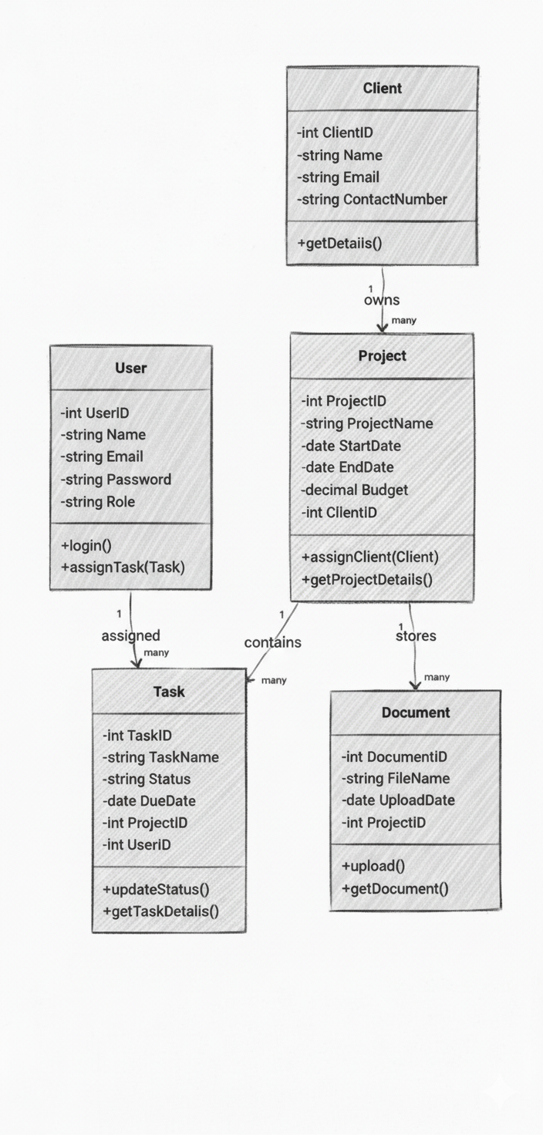

4.2OBJECT DIAGRAM
The Object Diagram represents specific instances of the classes in the system at a given point of time.
It gives a snapshot of the real-world data flowing through the system.
- Client Instance → Example: A client ABC Corp with ClientID 101, Email, and Contact Number.
- Project Instance → Example: A project ERP Implementation with ProjectID 201, linked to the client, with details like StartDate and Budget.
- User Instance → Example: A user John (UserID 301), acting as a Developer.
- Task Instance → Example: A task UI Development (TaskID 401), which is pending and assigned to John, and belongs to the ERP project.
- Document Instance → Example: A document Plan.doc uploaded on a specific date, associated with the ERP project.
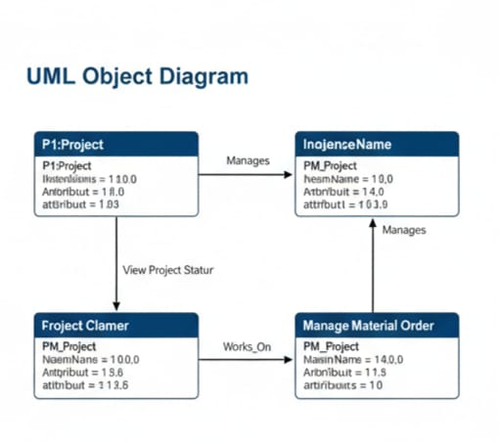

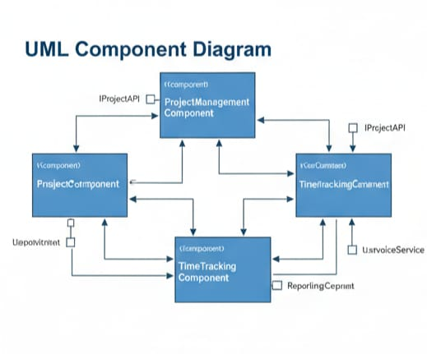
4.3 Component diagram

The Component Diagram of the Project Management System illustrates the modular structure of the software. It divides the system into different components that interact with each other to achieve the overall functionality.
1. User Interface (UI Layer)
- Represents the front-end of the system where users interact.
- Includes: Login Page, Dashboard, Project/Task/Document screens.
- Main role: Collect input from users and display results.
2. Application Layer (Business Logic Layer)
- Acts as the core processing unit of the system.
- Contains functional components:
  - User Management – manages user accounts, authentication, roles.
  - Project Management – handles project creation, budget, timelines.
  - Task Management – assigns tasks to users and tracks progress.
  - Document Management – stores and retrieves project files.
- Ensures business rules and workflows are followed.
🔹 3. Database Layer (Data Storage)
- Responsible for data persistence.
- Stores information in tables: Client, Project, User, Task, Document.
- Provides secure and structured storage with relationships defined by primary and foreign keys.
4. Interaction Flow
- User interacts with the UI Layer.
- UI sends the request to the Application Layer.
- Application Layer processes the request and communicates with the Database Layer.
- Database responds with the required data.
- Results are sent back through the Application Layer to the UI Layer for display.

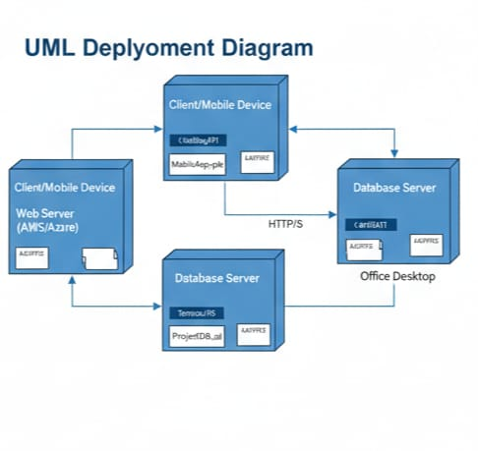
4.4 Deployement diagram

4.9 Deployment Diagram – Shaddo Construction
A Deployment Diagram represents the physical architecture of the system. It shows how software components are deployed on hardware nodes, illustrating the relationship between the system’s software and hardware environment.
For Shaddo Construction, the deployment diagram highlights the setup of the application, database, and client interactions in a real-world scenario.

Key Components:
1. Nodes (Hardware):
Client Machine: The computer or device used by construction staff or managers to access the system.
Web Server: Hosts the web application of Shaddo Construction. It processes client requests and serves the user interface.
Database Server: Stores all project-related data including project details, employee information, resource allocation, and timelines.

2. Artifacts (Software Components):
Shaddo Construction Application: The main software component deployed on the web server.
Database (e.g., MySQL/SQL Server): Deployed on the database server to manage data.
Web Browser/Client Interface: Deployed on the client machine to access the system.
3. Communication:
The client machine communicates with the web server through the internet or intranet using HTTP/HTTPS.
The web server interacts with the database server to retrieve and update project information

4.6Activity Diagram
Activity Diagram – Shaddo Construction
The Activity Diagram represents the workflow of Shaddo Construction. It shows the sequence of activities from the start to the completion of a construction project, including decisions and parallel processes. This diagram helps in understanding how tasks are performed, how resources are managed, and how progress is tracked.
Workflow:
1. Start: The process begins when a user (admin or staff) logs into the system.
2. Project Creation: Admin creates a new construction project with details like project name, start date, and end date.
3. Assign Tasks: Workers and resources are assigned to the project.
4. Manage Resources: Materials and machinery are allocated and tracked for each project task
5. Track Progress: Updates are made for project milestones and overall progress.
6. Decision Points:
If resources are sufficient → proceed with tasks.
If resources are insufficient → request additional resources.
If a milestone is completed → move to next phase.
If a milestone is delayed → notify admin and take corrective action.
7. Generate Reports: Project reports are produced for management review.
8. End: The process ends when the project is completed and all reports are finalized.

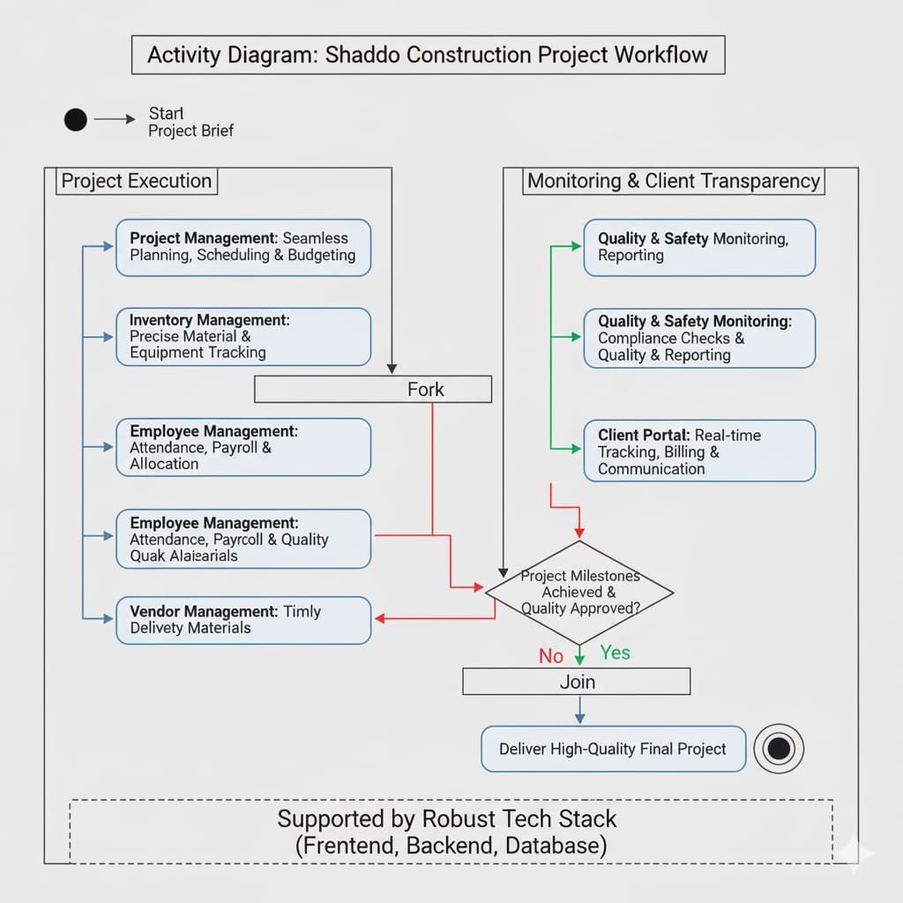

4.7 State Chart Diagram – Shaddo Construction
A State Chart Diagram shows the states of an object and transitions between them. For Shaddo Construction, it represents the lifecycle of a Project.
States:
- Planned – Project created with details.
- Resources Assigned – Workers, materials, and equipment allocated.
- Construction Started – Work begins on site.
- In Progress – Active execution of tasks.
- Inspection – Quality checks at milestones.
- Completed – Project fully done.
- Archived – Project records stored.
Transitions / Events:
- Plan → Assign Resources: Project plan approved.
- Assign Resources → Start Construction: Resources ready.
- Start → In Progress: Tasks begin.
- In Progress → Inspection: Milestone completed.
- Inspection → In Progress: Issues found → rework.
- Inspection → Completed: Passed inspection.
- Completed → Archived: Documentation finalized.
Notes: Loops allow rework after inspection; each state may have entry/exit act

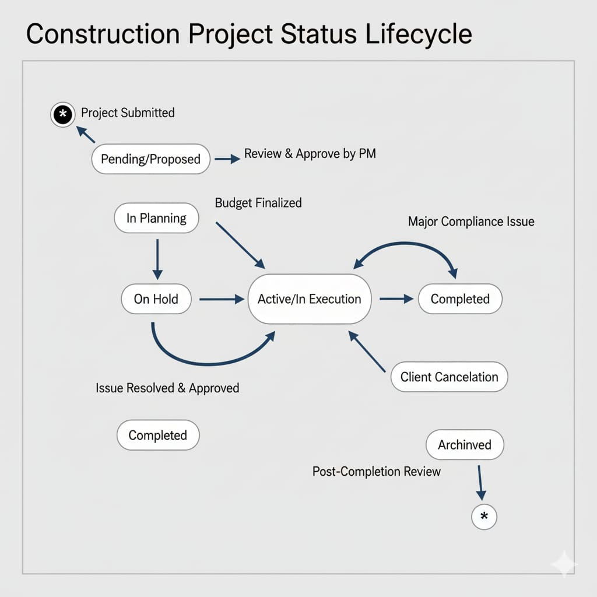

4.8Sequence Diagram for Shaddo Construction
A Sequence Diagram shows how objects or components interact over time in a specific scenario. It focuses on the order of messages exchanged between system components to perform a particular functionality.
Scenario: Creating a New Construction Project
Actors and Objects:
- Project Manager (Actor) – initiates project creation.
- System (Shaddo Construction Software) – processes requests and stores data.
- Database – stores project details.
- Worker/Staff Module – manages assigned staff for the project.
Flow of Interaction:
- Project Manager → System: Requests to create a new project.
- System → Database: Checks if the project ID already exists.
- Database → System: Confirms availability or returns error if duplicate.
- System → Database: Stores new project details (Project ID, Name, Start Date, End Date).
- System → Worker/Staff Module: Assigns staff/resources for the project.
- Worker/Staff Module → System: Confirms assignments.
- System → Project Manager: Sends confirmation that project has been successfully create

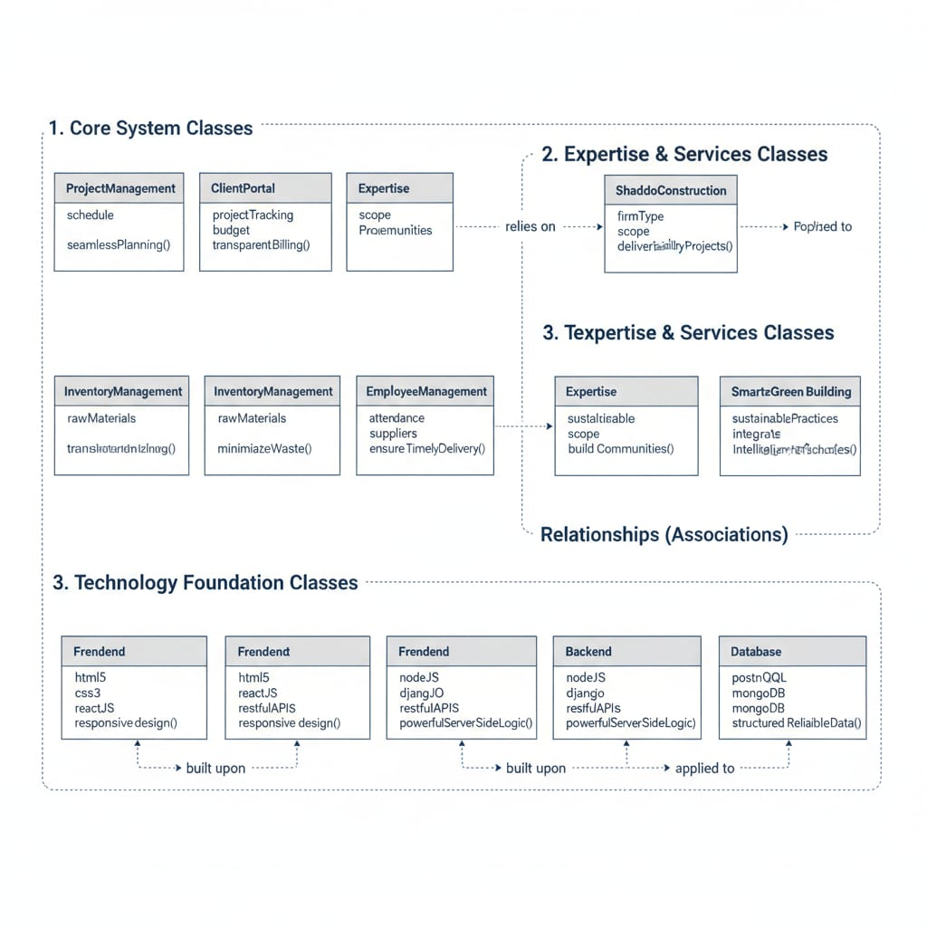

4.9 collaboration Diagram shows how objects in the system interact to carry out a task. It focuses on objects, their relationships, and the messages exchanged. Unlike sequence diagrams, it emphasizes structural organization along with interactions.
Objects in Shaddo Construction:
- Client – Requests a construction project and approves plans.
- ProjectManager – Manages project timelines, resources, and communication between teams.
- Architect – Designs building plans and submits designs for approval.
- Engineer – Checks structural feasibility and provides technical input.
- Contractor – Executes construction as per approved plans.
- Supplier – Supplies construction materials.
Relationships & Interactions:
- Client → ProjectManager: Sends project request.
- ProjectManager → Architect: Sends design requirements.
- Architect → Engineer: Sends design for technical review.
- Engineer → ProjectManager: Sends feedback or approval.
- ProjectManager → Contractor: Sends approved plan and timeline.
- Contractor → Supplier: Requests materials.
- Supplier → Contractor: Delivers materials.
- Contractor → ProjectManager: Updates progress.
- ProjectManager → Client: Sends project status and completion report.
